Competitor Website UX and Public Effectiveness Analysis for LearnAboutBees

1. Introduction and Purpose
This report presents a competitor website analysis conducted to support the design decision-making process for the LearnAboutBees project. The main purpose of this analysis is to understand how comparable websites structure their homepage, user interface, navigation, learning resources, purchase flow, mobile experience, and trust-building elements.
Instead of relying only on subjective observations, this analysis uses a structured scoring framework. Each competitor website was assessed through two main perspectives: UX performance and public website effectiveness. The UX evaluation focuses on how easy and clear the website is for users to understand and use. The public effectiveness evaluation focuses on publicly available indicators, including technical performance, search visibility, and social proof.
This approach helps identify which competitor websites provide useful design references, which UX areas commonly perform well, and which issues should be avoided when developing LearnAboutBees or improving Aphrodite’s Harvest.

2. Scope of the Review
The review included a selection of competitor and reference websites related to honey products, beekeeping education, local food brands, and beekeeping resource platforms. These websites were selected because they are relevant to the possible direction of LearnAboutBees, especially in terms of education, community engagement, local identity, product presentation, and online user journeys.
The analysis did not aim to measure actual internal business performance, sales, or real conversion rates, as these data are not publicly available. Instead, the evaluation used observable and publicly accessible indicators as proxies for website quality and effectiveness.

Table 1 List of reviewed competitor websites
No. | Website | URL | Positioning / Reference Value
1 | Beechworth Honey | https://www.beechworthhoney.com.au/ | Established Australian honey brand combining e-commerce, brand storytelling, educational content, and Bee School.
2 | Kangaroo Island Ligurian Bee Co. | https://kangarooislandbeeco.com.au/ | South Australian honey brand focusing on regional identity, rare Ligurian bees, pure origin, and premium honey.
3 | Buzz Honey | https://buzzhoney.com.au/ | Local Adelaide Hills honey brand; useful reference for a small local honey e-commerce website.
4 | Hayes Honey | https://www.hayeshoney.com.au/ | Adelaide raw honey brand highlighting raw, ethical, local, and small-scale production.
5 | NovaFarms Honey | https://www.novafarms.com.au/ | South Australian honey brand positioned around premium honey, Manuka honey, family ownership, and local production.
6 | WildEarth Beekeeping | https://wildearthbeekeeping.com.au/ | South Australian bee product and beekeeping-related website, covering honey, beeswax products, and some beekeeping content.
7 | Beerenberg | https://beerenberg.com.au/ | Established South Australian food brand; useful for benchmarking local produce storytelling, e-commerce experience, and visual design.
8 | Gumeracha Hills | https://www.gumerachahills.com.au/ | Local South Australian produce brand offering honey, olive oil, gift packs, beeswax, and related products.
9 | Trace Foodsteps | https://tracefoodsteps.com.au/ | South Australian local food e-commerce / marketplace platform; useful for product categorisation, producer profiles, and marketplace logic.
10 | Flow Hive | https://www.honeyflow.com.au/ | Well-known Australian beekeeping equipment and education brand combining product sales, beekeeping knowledge, courses, community, and support.
11 | Bee Inspired | https://bee-inspired.com.au/ | Australian beekeeping education and mentoring website; useful reference for small education-focused websites, course presentation, and community positioning.
12 | The Basin Backyard | https://www.tbbyard.com.au/ | Website combining honey, beekeeping supplies, and educational content; useful reference for a shop + education hybrid model.
13 | Beeman Honey | https://beemanhoney.com.au/ | Honey and beekeeping education-related website; useful for analysing how courses, education products, and honey sales are combined.

3. Evaluation Method
The analysis was divided into two major parts.
First, the UX audit assessed how well each website supports user understanding and task completion. The UX dimensions included homepage clarity, navigation, call-to-action design, learning resource visibility, product or service findability, user flow, mobile usability, UI consistency, readability, trust elements, and contact accessibility.
Second, the website effectiveness assessment used publicly available data to evaluate how well each website performs in publicly visible indicators. This included technical performance from PageSpeed Insights, search visibility through Google search checks, and social proof through Google Reviews, social media followers, testimonials, newsletter availability, and public contact information.
Each dimension was converted into a numerical score, allowing the competitor websites to be compared more consistently. The final analysis used descriptive statistics, rankings, functional classification, correlation analysis, and quadrant analysis.

The specific scoring dimension fields are shown in Appendix Table 4.

4. Functional Classification of Websites
To make the analysis more relevant to LearnAboutBees, the websites were not only grouped by business type. Instead, they were reclassified based on two functional features:
- whether the website supports an online payment, purchase, cart, checkout, or booking flow;
- whether the website provides structured learning resources.
Blog posts and FAQ pages were not counted as structured learning resources, because they do not necessarily represent a clear educational pathway. Based on these two criteria, the websites were grouped into three functional categories:
- Online Payment + Learning Resources
- Online Payment Only
- No Online Payment / No Learning Resources
This classification is more useful than a general business category because it directly reflects the design decisions that LearnAboutBees may need to make.
Functional classification only counted structured learning pathways, such as courses, resource libraries, or clear learning systems. In contrast, the Learning Resources score also considered broader educational content such as blogs, FAQ pages, or informational materials. Therefore, some websites may have educational content but still not be classified as Online Payment + Learning Resources.

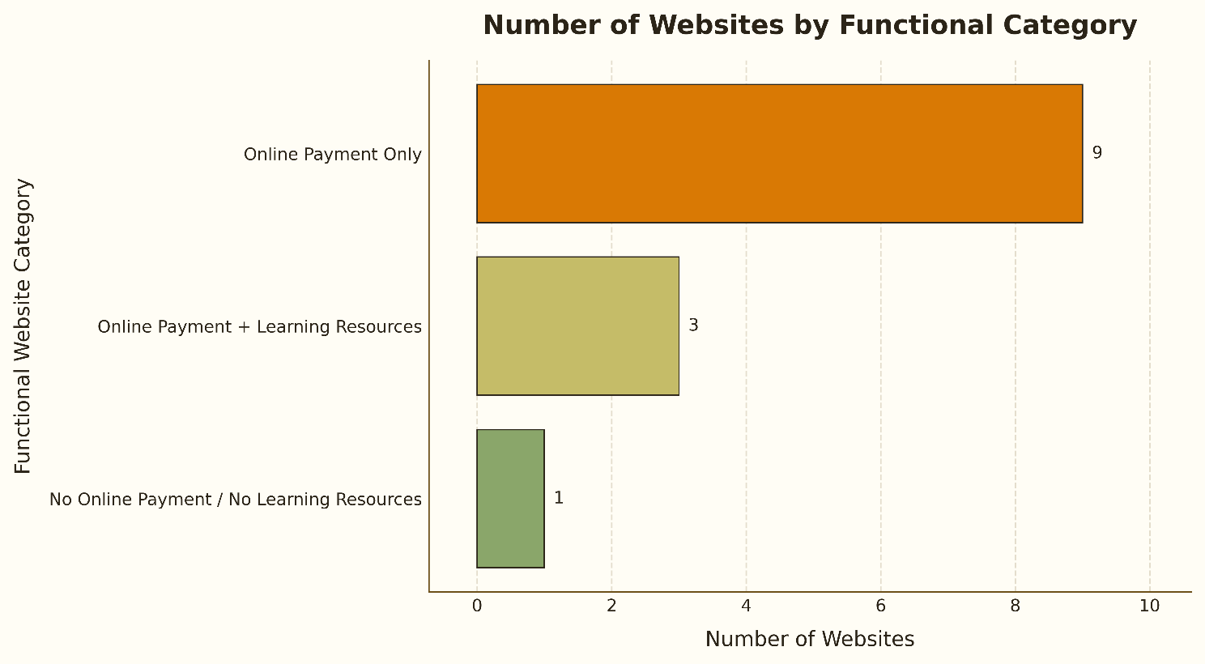
Figure 1 Number of Websites by Functional Category

Table 2 Functional category classification table
website_name | functional_category
Beechworth Honey | Online Payment Only
Kangaroo Island Ligurian Bee Co. | Online Payment Only
Buzz Honey | Online Payment Only
Hayes Honey | Online Payment Only
NovaFarms Honey | Online Payment Only
WildEarth Beekeeping | Online Payment Only
Beerenberg | Online Payment Only
Gumeracha Hills | No Online Payment / No Learning Resources
Trace Foodsteps | Online Payment Only
Flow Hive | Online Payment + Learning Resources
Bee Inspired | Online Payment + Learning Resources
The Basin Backyard | Online Payment + Learning Resources
Beeman Honey | Online Payment Only

5. Overall Findings Overview
The initial results show that most competitor websites achieved relatively strong UX scores, with many websites scoring above 80. Beeman Honey, Hayes Honey, WildEarth Beekeeping, and Flow Hive received the highest UX scores, suggesting that these websites provide comparatively clearer navigation, stronger task flows, and more complete user-facing functions.
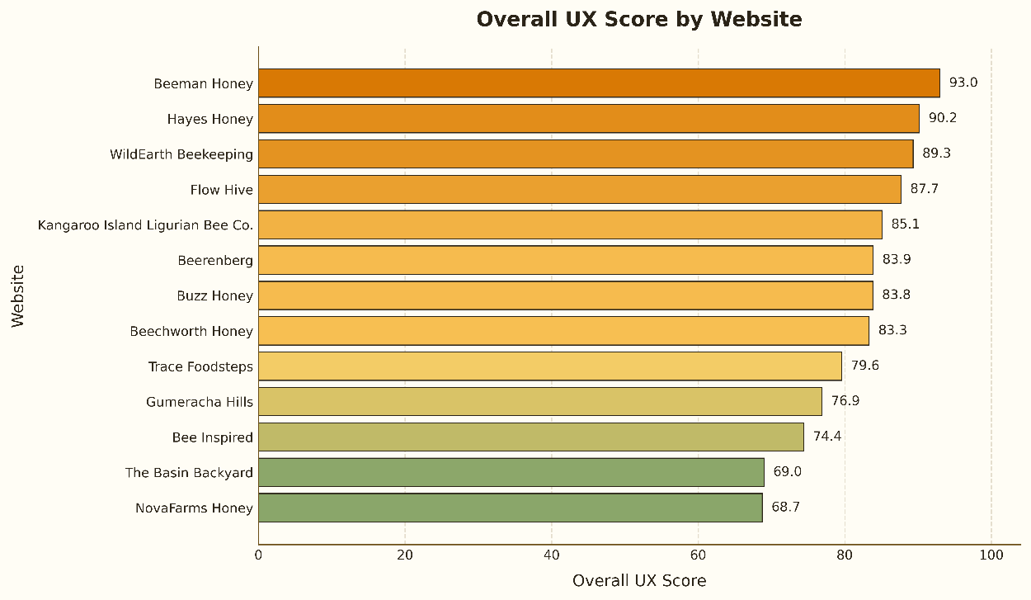
Figure 2 Overall UX Score by Website

The website effectiveness results show a slightly different pattern. Beeman Honey, Beerenberg, The Basin Backyard, Beechworth Honey, and Flow Hive performed strongly in public effectiveness. This indicates that some websites may be stronger in public visibility, technical performance, or trust indicators, even if their UX score is not the highest.

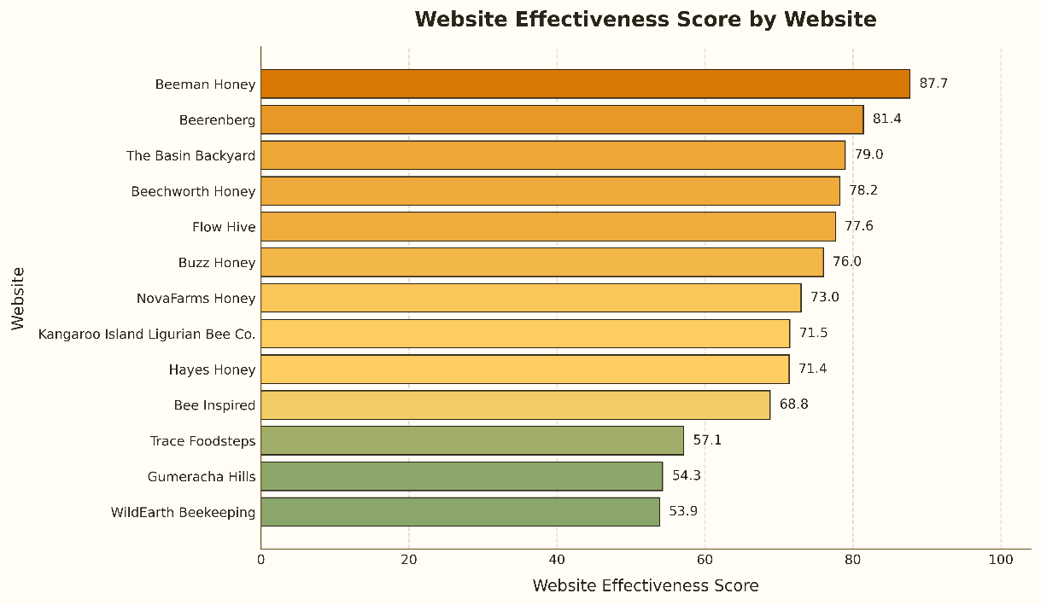
Figure 3 Website Effectiveness Score by Website

The quadrant analysis provides an overview of how UX performance and website effectiveness compare. Websites in the upper-right area, such as Beeman Honey, Flow Hive, Beechworth Honey, Beerenberg, and Buzz Honey, appear to be the most useful benchmark examples at this stage because they show both relatively strong UX and relatively strong public effectiveness.
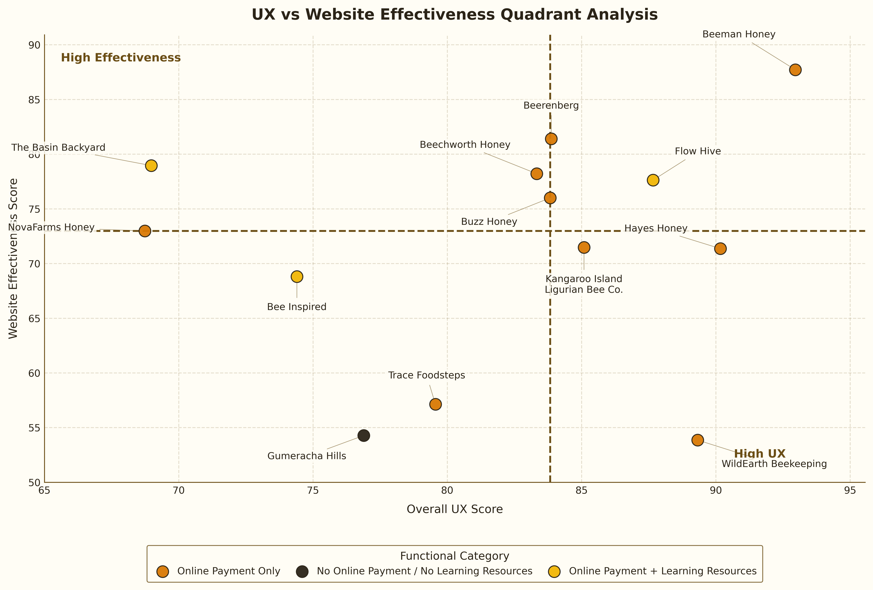
Figure 4 UX vs Website Effectiveness Quadrant Analysis by Functional Category

Overall, the initial analysis suggests that strong competitor websites usually combine clear user journeys, visible action points, functional navigation, and stronger public trust or visibility. However, some websites perform well in only one area, which means the following detailed analysis should examine both what these websites do well and where common UX gaps still exist.

6. Correlation Analysis Findings
The correlation analysis was used to explore the relationship between UX dimensions and public website effectiveness. Because the sample size is limited, the results should be treated as indicative rather than conclusive.
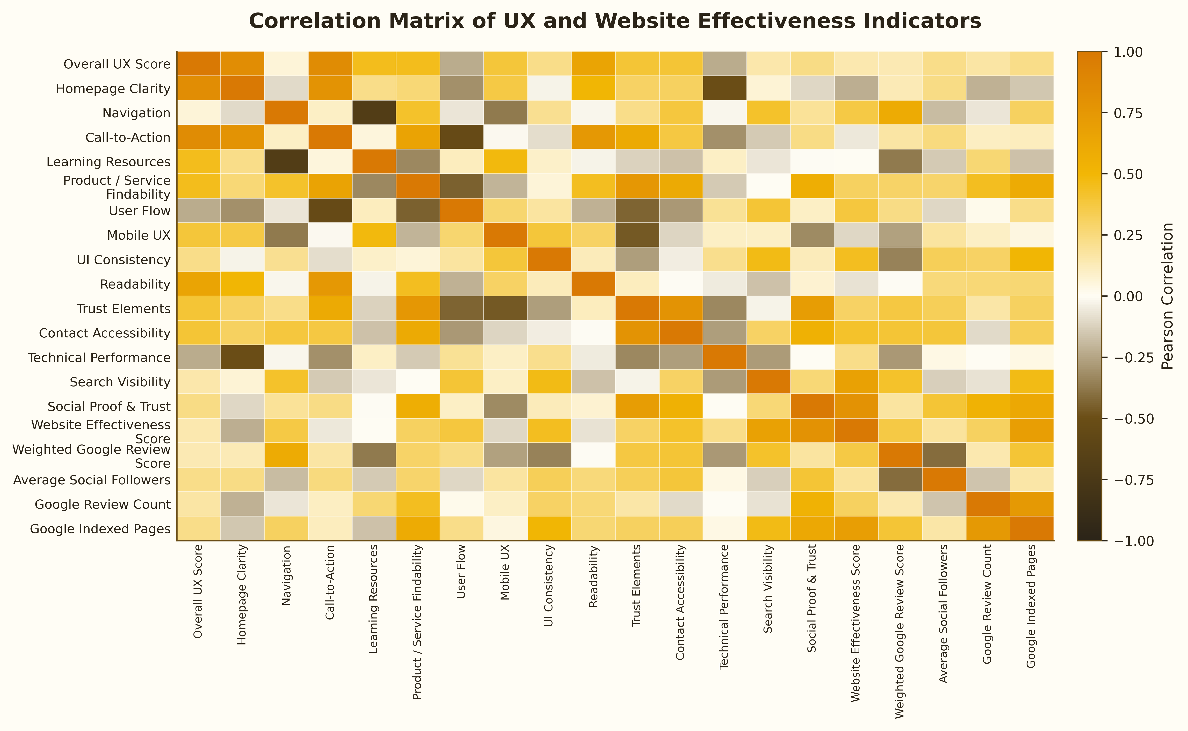
Figure 5 Correlation Matrix of UX and Website Effectiveness Indicators

The correlation matrix shows that relationships between UX dimensions and website effectiveness vary across indicators in this sample. Some UX dimensions had clearer positive associations with effectiveness, while others showed weaker or mixed relationships.
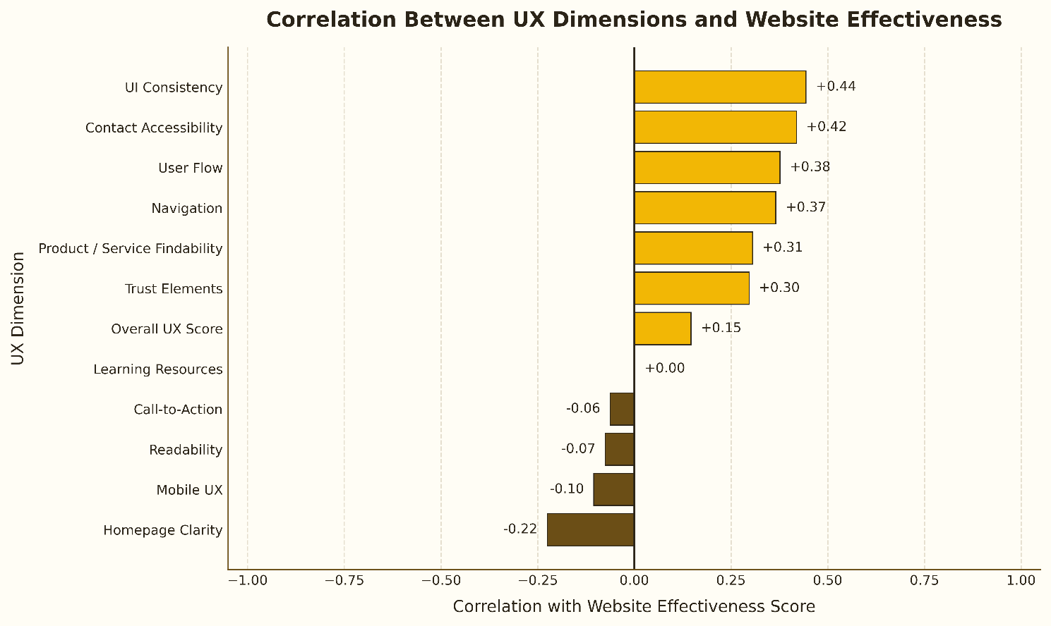
Figure 6 Correlation Between UX Dimensions and Website Effectiveness

The strongest positive correlations with website effectiveness were found in UI Consistency, Contact Accessibility, User Flow, and Navigation. In this sample, websites with more consistent interface design, clearer contact access, smoother task flows, and easier navigation appeared to be associated with higher public effectiveness scores.
Other dimensions, such as Homepage Clarity, Mobile UX, Readability, and Call-to-Action, showed weaker or negative correlations in this dataset. This does not mean these areas are unimportant, but it shows that they were not strongly associated with the public effectiveness score among the reviewed websites.
Overall, the correlation results indicate that, in this sample, website effectiveness was more closely associated with practical usability factors, especially consistency, navigation, contact access, and user flow. These relationships should be interpreted as indicative rather than conclusive.

7. Website-Level UX Diagnosis and Common Problem Areas
The website-level diagnosis shows that several competitors achieved strong overall UX scores, but their strengths and weaknesses were not the same. Beeman Honey, Hayes Honey, WildEarth Beekeeping, and Flow Hive were rated as excellent in UX. These websites generally performed well in areas such as navigation, call-to-action design, mobile UX, homepage clarity, or user flow.
Table 3 Website-Level UX Diagnosis Table

Website Name | Functional Category | UX Level | Effectiveness Level | Top UX Strengths | Main UX Weaknesses
Beeman Honey | Online Payment Only | Excellent | Excellent | Navigation: 100.0; Call-to-Action: 100.0; Mobile UX: 100.0 | Trust Elements: 66.7; Product / Service Findability
Hayes Honey | Online Payment Only | Excellent | Moderate | Homepage Clarity: 100.0; Call-to-Action: 100.0 | UI Consistency: 45.5; Product / Service Findability
WildEarth Beekeeping | Online Payment Only | Excellent | Weak | Homepage Clarity: 100.0; Call-to-Action: 100.0 | Product / Service Findability: 45.5; Trust Elements
Flow Hive | Online Payment + Learning Resources | Excellent | Good | Call-to-Action: 100.0; Mobile UX: 100.0; UI Consistency | Learning Resources: 70.0; Navigation: 76.9; Trust Elements
Kangaroo Island Ligurian Bee Co. | Online Payment Only | Excellent | Moderate | Learning Resources: 100.0; Contact Accessibility | Readability: 42.9; UI Consistency: 63.6; Homepage Clarity
Beerenberg | Online Payment Only | Good | Good | Learning Resources: 100.0; Mobile UX: 100.0; UI Consistency | Homepage Clarity: 57.1; Trust Elements: 60.0
Buzz Honey | Online Payment Only | Good | Good | Learning Resources: 100.0; Mobile UX: 100.0; UI Consistency | Trust Elements: 40.0; Product / Service Findability
Beechworth Honey | Online Payment Only | Good | Good | Navigation: 100.0; Contact Accessibility: 100.0 | Learning Resources: 62.5; Homepage Clarity: 71.4
Trace Foodsteps | Online Payment Only | Good | Weak | Navigation: 100.0; Mobile UX: 100.0; Readability | Trust Elements: 40.0; Learning Resources: 50.0
Gumeracha Hills | No Online Payment / No Learning Resources | Good | Weak | Mobile UX: 100.0; User Flow: 88.9; Contact Accessibility | UI Consistency: 36.4; Trust Elements: 60.0; Product / Service Findability
Bee Inspired | Online Payment + Learning Resources | Moderate | Moderate | User Flow: 91.9; Call-to-Action: 87.5; Readability | UI Consistency: 45.5; Homepage Clarity: 57.1
The Basin Backyard | Online Payment + Learning Resources | Moderate | Good | User Flow: 94.6; Navigation: 92.3; Mobile UX | Readability: 28.6; Call-to-Action: 37.5; Learning Resources
NovaFarms Honey | Online Payment Only | Moderate | Moderate | Learning Resources: 100.0; User Flow: 100.0 | Call-to-Action: 0.0; Product / Service Findability

However, the diagnosis table also shows that high overall UX scores do not mean every UX area is strong. Some websites still had weaknesses in trust elements, product or service findability, UI consistency, or learning resources. This means that even strong competitor websites have specific design gaps that LearnAboutBees should consider carefully.
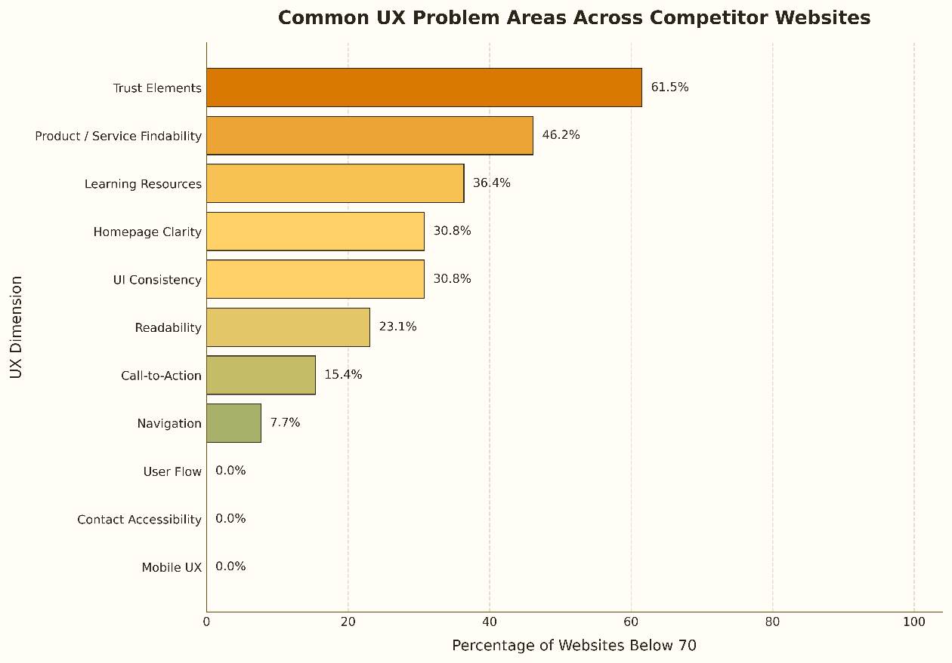
Figure 7 Common UX Problem Areas Across Competitor Websites
The common problem analysis shows that Trust Elements were the most frequent UX issue, with 61.5% of websites scoring below 70 in this dimension. This indicates that many competitor websites did not provide enough visible trust signals, such as testimonials, Google reviews, certifications, real photos, local identity, or clear credibility information.
The second most common issue was Product / Service Findability, with 46.2% of websites scoring below 70. This suggests that some websites made it difficult for users to quickly find products, services, courses, or relevant actions.
Learning Resources were also a common weakness, with 36.4% of websites scoring below 70. This is especially relevant to LearnAboutBees, because the future website may need to present learning content in a clearer and more structured way.
Other repeated issues included Homepage Clarity and UI Consistency, both affecting 30.8% of websites. These findings suggest that some competitors still struggle to communicate their purpose clearly on the homepage or maintain a consistent visual design across the site.
In contrast, Mobile UX, Contact Accessibility, and User Flow showed fewer common problems in this sample. This suggests that many reviewed websites were generally usable on mobile and provided acceptable paths for basic user tasks.

Limitations
This review is based on publicly observable website features and publicly available performance indicators. It does not include internal analytics data, real conversion rates, sales data, or direct user testing. Therefore, the results should be interpreted as a structured UX benchmark rather than a complete business performance evaluation.

8. Conclusion and Design Implications for LearnAboutBees
Overall, the competitor review shows that a strong website needs more than an attractive visual design. The strongest examples combined clear navigation, visible user actions, smooth user flows, credible trust signals, structured learning resources, and strong public website effectiveness. For LearnAboutBees, this is especially important because the intended direction is to become a combined e-commerce and learning resource website, rather than only an information site or only an online shop.
For LearnAboutBees, the key design challenge is not only to sell products or provide information, but to connect these two functions in a clear user journey. The competitor review shows that many websites are stronger in one function than the other. Therefore, LearnAboutBees should use UX design to reduce confusion between shopping and learning, guide beginners clearly, and build trust before users make a purchase or engage with learning content.
The analysis shows that websites with online payment functions often perform well in user flow and action design, because they need to guide users clearly toward products, carts, checkout, or booking actions. At the same time, websites with learning resources provide useful references for how to structure educational content. However, not every website successfully combines both functions. Some websites are strong in e-commerce but weak in learning structure, while others provide learning content but have weaker purchase or conversion pathways.
Therefore, LearnAboutBees should not copy one competitor directly. Instead, it should combine the strongest features from different benchmark websites. Websites such as Beeman Honey, Flow Hive, Beechworth Honey, Beerenberg, and Buzz Honey are useful references because they show different strengths in UX, public effectiveness, product presentation, learning content, trust-building, or user flow.
The most common UX issue across the reviewed websites was weak trust elements. Many websites did not provide enough visible evidence to help users feel confident, such as testimonials, reviews, real photos, certifications, local identity, or clear credibility information. Product or service findability was also a repeated weakness. For LearnAboutBees, this is particularly important because users should be able to quickly find both products and learning resources without confusion.
Based on the findings, LearnAboutBees should prioritise the following design directions:
- Clear dual-purpose homepage positioning
The homepage should immediately explain that LearnAboutBees offers both beekeeping-related products and learning resources. Users should be able to quickly choose between shopping, learning, or exploring beginner guidance.
- Separate but connected Shop and Learn pathways
The website should clearly separate the Shop pathway and the Learn pathway in navigation, while still connecting them where relevant. For example, beginner learning pages can recommend related starter products, and product pages can link to relevant guides.
- Structured learning resource system
Learning resources should not be presented as scattered information. The site should include a clear structure such as “Start Here”, “Beginner Resources”, “Courses”, “Guides”, and “Advanced Topics”.
- Smooth e-commerce user flow
Users should be able to move from homepage to product categories, product pages, cart, and checkout in as few steps as possible. Product information, prices, calls-to-action, and purchase options should be clear.
- Strong trust-building elements
Because LearnAboutBees will involve both education and online purchasing, trust is critical. The website should include real photos, local identity, testimonials, clear contact details, reviews, and any relevant credentials or partnerships.
- Consistent UI and mobile-friendly design
Buttons, colours, typography, spacing, and page layouts should remain consistent across the website. The mobile experience should be prioritised because users may browse products, read resources, or contact the business from mobile devices.
- Public effectiveness considerations
The website should also be designed with technical performance, search visibility, and social proof in mind. This includes fast loading speed, basic SEO structure, clear page titles, accessible content, and visible social or review signals.
In conclusion, the main opportunity for LearnAboutBees is to position itself as a clear, trustworthy, and easy-to-use platform that combines e-commerce and beekeeping learning resources. The competitor analysis suggests that the best design direction is not simply to add more features, but to organise the two core functions clearly: users should be able to shop easily, learn easily, and understand how the products and educational resources support each other.

9. Priority Recommendations for LearnAboutBees
The following priorities translate the competitor review findings into practical design actions for LearnAboutBees.
Priority | Recommendation | Reason
High | Clear homepage positioning: Shop + Learn | Users need to immediately understand that the website provides both products and learning resources.
High | Separate but connected Shop and Learn pathways | This reduces confusion and supports different user goals.
High | Strong trust-building elements | Trust elements were one of the most common UX weaknesses across competitor websites.
Medium | Structured learning resource system | This supports LearnAboutBees as more than a simple online shop.
Medium | Product/service findability | Users should be able to quickly find products, courses, and learning resources.
Medium | Mobile-friendly and consistent UI | Mobile users need a smooth experience for browsing, learning, and purchasing.

10. Example Website Demo Based on UX Review Findings
To connect the findings with a practical design example, a sample LearnAboutBees website demo was created: learnaboutbees-demo.vercel.app. This demo is only an example and should not be treated as a final production website.
The design concept is based on the UX review conclusions in this report. It demonstrates how LearnAboutBees could combine clear homepage positioning, separate but connected Shop and Learn pathways, beginner guidance, learning resources, trust signals, and a consistent mobile-friendly interface into one clearer user journey.

Appendix
Table 4 Summary of scoring dimensions
Basic Information
Field Name | Type | Brief Description
website_name | Text | Name of the website
url | Text | Website URL
category | Categorical | Website type, such as honey e-commerce, education, or marketplace
target_user_type | Categorical | Main target users
primary_goal | Categorical | Main purpose of the website

Homepage Clarity
Field Name | Type | Brief Description
hero_section_present | Binary | Whether the homepage has a clear hero section
clear_value_proposition | Binary | Whether the website value is clearly explained
target_user_clear | Binary | Whether the target audience is clear
product_or_service_visible_above_fold | Binary | Whether key products, courses, or services are visible above the fold
primary_cta_above_fold | Binary | Whether the main call-to-action appears above the fold
homepage_clarity_score | Numeric | Overall homepage clarity score

Navigation
Field Name | Type | Brief Description
main_navigation_present | Binary | Whether the website has a main navigation bar
navigation_items_count | Numeric | Number of main navigation items
has_shop_nav | Binary | Whether Shop or Products is included
has_learn_nav | Binary | Whether Learn, Resources, or Education is included
has_about_nav | Binary | Whether About or Our Story is included
has_contact_nav | Binary | Whether Contact is included
has_search_function | Binary | Whether a search function is available
mobile_hamburger_menu | Binary | Whether mobile navigation uses a hamburger menu
navigation_error_present | Binary | Whether obvious navigation errors are present
navigation_score | Numeric | Overall navigation score

User Flow
Field Name | Type | Brief Description
clicks_home_to_product | Numeric | Clicks needed from homepage to product page
clicks_home_to_checkout | Numeric | Clicks needed from homepage to checkout
clicks_home_to_course | Numeric | Clicks needed from homepage to course page
clicks_home_to_learning_resource | Numeric | Clicks needed from homepage to learning resources
clicks_home_to_contact | Numeric | Clicks needed from homepage to contact page
product_purchase_flow_available | Binary | Whether online purchase is available
course_booking_flow_available | Binary | Whether online course booking is available
contact_form_available | Binary | Whether a contact form is available
broken_link_found | Binary | Whether broken links are found
user_flow_score | Numeric | Overall user flow score

Call-to-Action
Field Name | Type | Brief Description
primary_cta_text | Text | Text of the main CTA button
primary_cta_present | Binary | Whether a main CTA is present
cta_count_homepage | Numeric | Number of CTA buttons on the homepage
cta_action_specific | Binary | Whether CTA wording is action-specific
cta_visual_prominence | Ordinal | Visual prominence of CTA
cta_consistent_style | Binary | Whether CTA style is consistent
cta_matches_site_goal | Binary | Whether CTA matches the website goal
cta_score | Numeric | Overall CTA score

Learning Content Findability
Field Name | Type | Brief Description
learning_section_present | Binary | Whether learning or education content is present
beginner_content_present | Binary | Whether beginner-friendly content is present
course_page_present | Binary | Whether a course page is present
resource_library_present | Binary | Whether a resource library is present
faq_present | Binary | Whether an FAQ section is present
blog_or_articles_present | Binary | Whether blogs or articles are present
learning_pathway_present | Binary | Whether a learning pathway is provided
learning_content_depth | Ordinal | Depth of learning content
clicks_home_to_learning | Numeric | Clicks needed from homepage to learning content
learning_score | Numeric | Overall learning content score

Product / Service Findability
Field Name | Type | Brief Description
product_page_present | Binary | Whether product pages are present
product_categories_present | Binary | Whether product categories are present
product_filter_present | Binary | Whether product filtering is available
product_search_present | Binary | Whether product search is available
product_price_visible | Binary | Whether product prices are clear
product_image_quality | Ordinal | Quality of product images
add_to_cart_available | Binary | Whether add-to-cart is available
product_description_complete | Ordinal | Completeness of product descriptions
product_findability_score | Numeric | Overall product findability score

Mobile UX
Field Name | Type | Brief Description
mobile_layout_responsive | Binary | Whether the layout is mobile responsive
mobile_nav_working | Binary | Whether mobile navigation works properly
mobile_text_readable | Binary | Whether mobile text is readable
mobile_buttons_tappable | Binary | Whether buttons are easy to tap
mobile_no_horizontal_scroll | Binary | Whether there is no horizontal scrolling
mobile_images_scaled | Binary | Whether images scale properly
mobile_no_overlap | Binary | Whether there is no element overlap
mobile_cta_visible | Binary | Whether CTA is visible on mobile
mobile_ux_score | Numeric | Overall mobile UX score

UI Consistency
Field Name | Type | Brief Description
consistent_button_style | Binary | Whether button styles are consistent
consistent_font_style | Binary | Whether font styles are consistent
consistent_color_palette | Binary | Whether the colour palette is consistent
consistent_spacing | Binary | Whether page spacing is consistent
consistent_image_style | Binary | Whether image style is consistent
consistent_card_layout | Binary | Whether card layouts are consistent
visual_error_count | Numeric | Number of visible UI errors
ui_consistency_score | Numeric | Overall UI consistency score

Readability
Field Name | Type | Brief Description
body_text_readable | Binary | Whether body text is easy to read
font_size_adequate | Binary | Whether font size is adequate
text_contrast_adequate | Binary | Whether text contrast is adequate
paragraph_length_reasonable | Binary | Whether paragraph length is reasonable
headings_used_clearly | Binary | Whether headings are used clearly
bullet_or_cards_used | Binary | Whether bullets or cards support readability
excessive_text_blocks_present | Binary | Whether excessive text blocks are present
readability_score | Numeric | Overall readability score

Trust Elements
Field Name | Type | Brief Description
about_page_present | Binary | Whether an About page is present
founder_story_present | Binary | Whether founder or brand story is present
real_photos_present | Binary | Whether real photos are used
testimonials_present | Binary | Whether testimonials are present
google_reviews_linked | Binary | Whether Google Reviews are linked
certifications_present | Binary | Whether certifications, awards, or association logos are present
contact_details_visible | Binary | Whether contact details are visible
social_links_present | Binary | Whether social media links are present
location_local_identity_present | Binary | Whether local identity is highlighted
trust_score | Numeric | Overall trust score

Contact Accessibility
Field Name | Type | Brief Description
contact_page_present | Binary | Whether a Contact page is present
contact_nav_visible | Binary | Whether Contact is visible in navigation
email_visible | Binary | Whether email address is visible
phone_visible | Binary | Whether phone number is visible
physical_address_visible | Binary | Whether physical address is visible
contact_form_present | Binary | Whether a contact form is present
social_contact_available | Binary | Whether social media contact is available
opening_hours_present | Binary | Whether opening hours are shown
clicks_home_to_contact | Numeric | Clicks needed from homepage to contact page
contact_score | Numeric | Overall contact accessibility score

Technical Performance
Field Name | Type | Data Source | Brief Description
pagespeed_mobile_performance | Numeric 0–100 | PageSpeed Insights | Mobile performance score
pagespeed_desktop_performance | Numeric 0–100 | PageSpeed Insights | Desktop performance score
accessibility_score | Numeric 0–100 | PageSpeed / Lighthouse | Website accessibility score
best_practices_score | Numeric 0–100 | PageSpeed / Lighthouse | Best practices score
seo_lighthouse_score | Numeric 0–100 | PageSpeed / Lighthouse | Lighthouse SEO score
lcp_mobile | Numeric | PageSpeed Insights | Mobile Largest Contentful Paint score
inp_mobile | Numeric | PageSpeed Insights | Mobile Interaction to Next Paint score
cls_mobile | Numeric | PageSpeed Insights | Mobile Cumulative Layout Shift score
core_web_vitals_pass | Binary / NA | PageSpeed Insights | Whether the website passes Core Web Vitals

Search Visibility
Field Name | Type | Data Source | Brief Description
indexed_pages_google | Numeric / NA | Google search: site:domain.com | Estimated number of indexed pages on Google
brand_search_google_business_present | Binary | Google brand search | Whether Google Business Profile appears in brand search
brand_search_top_result_correct | Binary | Google brand search | Whether the official website appears as the top result
organic_keywords_count | Numeric / NA | Semrush / Ahrefs | Estimated number of organic search keywords
organic_traffic_estimate | Numeric / NA | Semrush / Ahrefs | Estimated organic search traffic

Social Proof and Trust
Field Name | Type | Data Source | Brief Description
google_review_rating | Numeric / NA | Google brand search | Google review rating
google_review_count | Numeric / NA | Google Business Profile | Number of Google reviews
instagram_followers | Numeric / NA | Instagram page | Number of Instagram followers
facebook_followers | Numeric / NA | Facebook page | Number of Facebook followers
social_links_count | Numeric | Website footer / homepage | Number of social media platforms linked on the website
testimonials_count | Numeric | Website manual review | Number of testimonials displayed on the website
newsletter_signup_present | Binary | Website manual review | Whether newsletter signup is available
contact_information_public | Binary | Website manual review | Whether public contact information is available

